

DAA PRACTICAL FILE

2022-2023
(IV SEMESTER)

NAME: SWASTIKA JAIN
SECTION: F
CLASS ROLL NUMBER: 32
UNIVERSITY ROLL NUMBER: 2017080

WEEK 1

1.
#include <iostream>
using namespace std;
int main() {
int T;
cin >> T;
for (int i = 0; i < T; i++) {
int n;
cin >> n;
int A[1000];
for (int j = 0; j < n; j++) {
cin >> A[j];
}
int flag = 0, comp = 0, key;
cin >> key;
for (int k = 0; k < n; k++) {
comp++;
if (A[k] == key) {
flag++;
cout << "Present ";
break;
}
}
if (flag == 0)
cout << "Not present ";
cout << comp << endl;
}
}

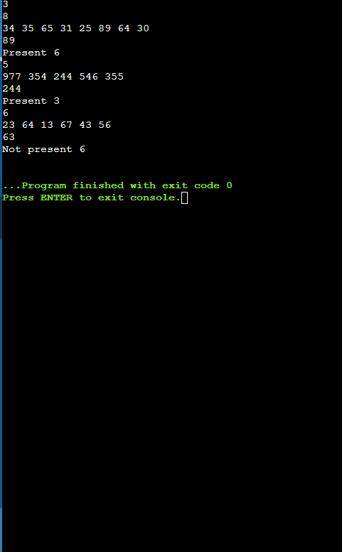

2.
#include <iostream>
using namespace std;
int main() {
int T;
cin >> T;
for (int i = 0; i < T; i++) {
int n;
cin >> n;
int A[1000];
for (int j = 0; j < n; j++)
cin >> A[j];
int flag = 0, comp = 0, key, mid, lower = 0, greater = n - 1
cin >> key;
while (greater >= lower) {
comp++;
mid = lower + (greater - lower) / 2;
if (A[mid] == key) {
cout << "Present ";
flag++; break;
}
else if (key > A[mid])
lower = mid + 1;
else
greater = mid - 1;
}
if (flag == 0) cout << "Not Present ";
cout << comp << endl;
}
}
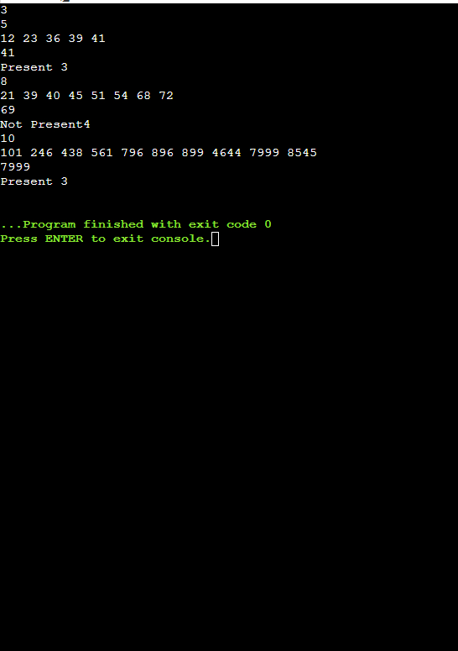

WEEK 2
1.
#include <iostream>
#include <vector>
#include <algorithm>
using namespace std;
int count(int A[], int key, int n) {
int *l = lower_bound(A, A + n, key);
if (l == (A + n) || *l != key)
return 0;
int *f = upper_bound(l, A + n, key);
return f - l;
}
int main() {
int T, n;
cin >> T;
for (int j = 0; j < T; j++){
cin >> n;
int lb = 0, ub = n - 1;
int A[1000];
for (int i = 0; i < n; i++)
cin >> A[i];
int key, c;
cin >> key;
c = count(A, key, n);
if (c == 0)
cout << "Key not present" << endl;
cout << key << " - " << c << endl;
}
}
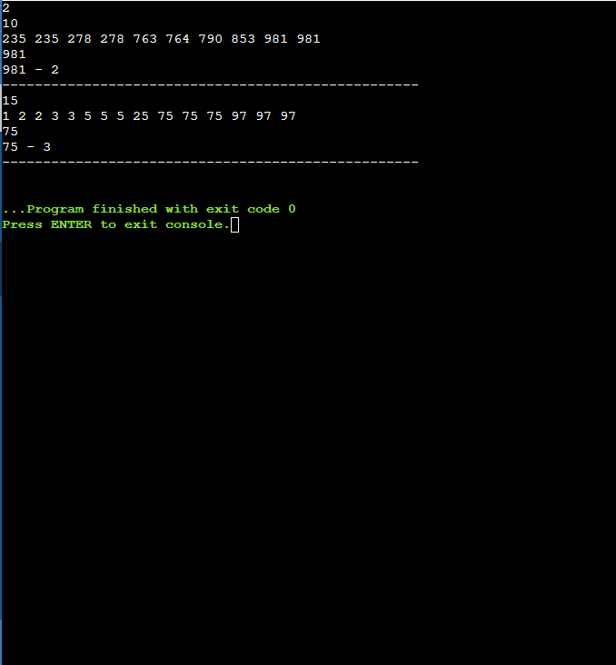

2.
#include <iostream>
using namespace std;
int main() {
int T;
cin >> T;
for (int m = 0; m < T; m++) {
int A[1000];
int n;
cin >> n;
for (int i = 0; i < n; i++)
cin >> A[i];
int i, j, k;
int flag = 0;
for (int i = 0; i < n; i++) {
for (int j = i + 1; j < n; j++) {
int sum = A[i] + A[j];
for (int k = 0; k < n; k++) {
if (sum == A[k]) {
flag = 1;
cout << i << " " << j << " " << k << endl;
break;
}
}
}
}
if (flag == 0)
cout << "Sequence not found" << endl;
}
}
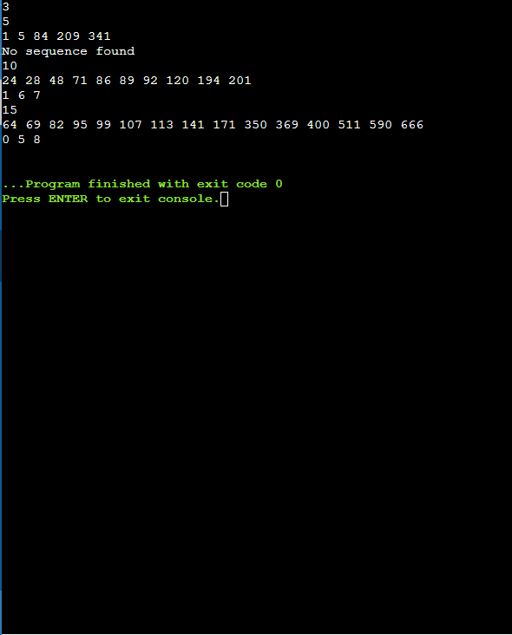

3.
#include <iostream>
using namespace std;
int main() {
int T;
cin >> T;
for (int i = 0; i < T; i++) {
int n;
cin >> n;
int A[1000];
for (int j = 0; j < n; j++)
cin >> A[j];
int key;
cin >> key;
int count = 0;
for (int j = 0; j < n; j++) {
for (int k = j + 1; k < n; k++) {
if (A[j] - A[k] == key || A[k] - A[j] == key)
count++;
}
}
cout << count << endl;
cout << "-----------------------------" << endl;
}
}

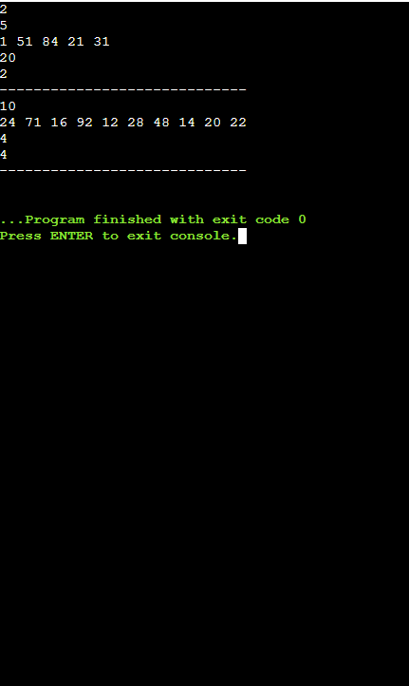
WEEK 3
1.
#include <iostream>
using namespace std;

void Insert_Sort(int[], int);
int main() {
int T;
cin >> T;
for (int i = 0; i < T; i++)
{
int n;
cin >> n;
int A[1000];
for (int j = 0; j < n; j++)
cin >> A[j];

Insert_Sort(A, n);
}
}

void Insert_Sort(int A[], int n) {
int temp, comp = 0, shift = 0;
for (int i = 1; i < n; i++) {
temp = A[i];
int j = i - 1;

while (j >= 0 && A[j] > temp){
comp++;
A[j + 1] = A[j];
shift++; j--;
}
A[j + 1] = temp;
shift++;
}

for (int i = 0; i < n; i++)
cout << A[i] << " ";
cout << "\ncomparisons = " << comp
<< endl << "shifts = " << shift << endl;
}

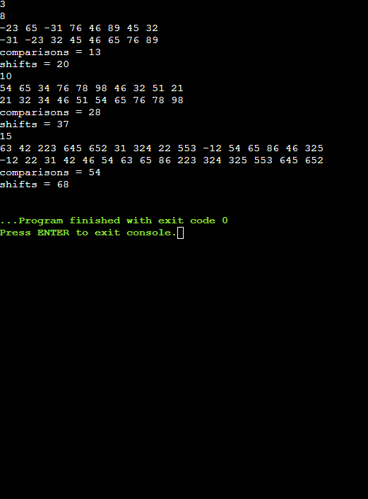

2.
#include <iostream>
using namespace std;

void Sel_Sort(int[], int);

int main()
{
int T;
cin >> T;
for (int i = 0; i < T; i++)
{
int n;
cin >> n;
int A[1000];
for (int j = 0; j < n; j++)
{
cin >> A[j];
}

Sel_Sort(A, n);
}
}
void Sel_Sort(int A[], int n)
{
int comp = 0, swaps = 0;
int min, temp = 0;

for (int i = 0; i < n - 1; i++)
{
min = i;
for (int j = i + 1; j < n; j++)
{
comp++;
if (A[min] > A[j])
{
min = j;
}
}
swaps++;
swap(A[min], A[i]);
}

for (int i = 0; i < n; i++)
{
cout << A[i] << " ";
}

cout << "\ncomparisons = " << comp << endl
<< "swaps = " << swaps << endl;
}

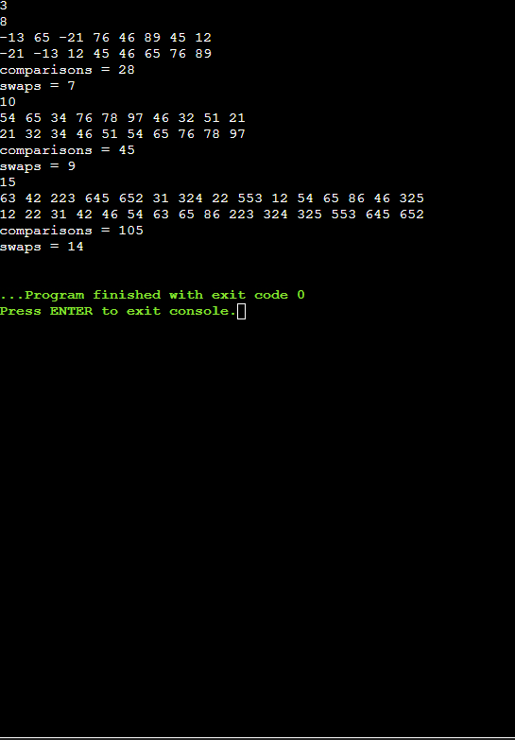

3.
#include <iostream>
using namespace std;
void Quick_Sort(int[], int, int);
int main()
{
int T;
cin >> T;
for (int i = 0; i < T; i++)
{
int n;
cin >> n;
int A[1000];
for (int j = 0; j < n; j++)
cin >> A[j];

Quick_Sort(A, 0, n - 1);

int flag = 0;
for (int j = 0; j < n; j++)
{
if (A[j] == A[j + 1])
{
flag = 1;
cout << "YES" << endl;
break;
}
}

if (flag == 0)
cout << "NO" << endl;
}
}

void Quick_Sort(int a[], int lb, int ub)
{
int i = lb, j = ub, key = a[lb];

if (i > j)
return;

while (i < j)
{
while (key >= a[i] && i < j)
i++;
while (key < a[j])
j--;
if (i < j)
{
int t = a[i];
a[i] = a[j];
a[j] = t;
}
}
a[lb] = a[j];
a[j] = key;

Quick_Sort(a, lb, j - 1);
Quick_Sort(a, j + 1, ub);
}
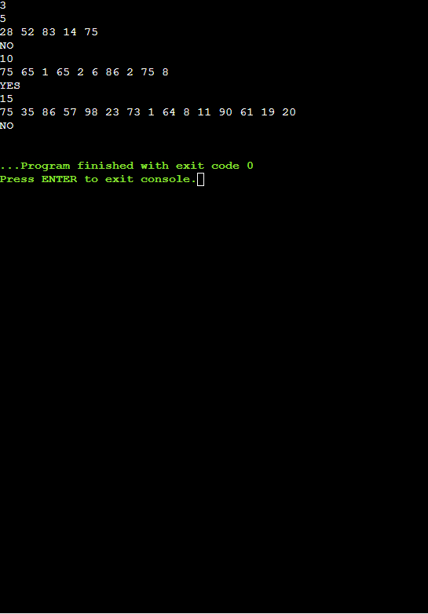
WEEK 4
1.
#include <iostream>
using namespace std;
int comp = 0;
int merge(int arr[], int l, int mid, int h) {
int count = 0;
int i = l, j = mid + 1;
int temp[1000];
int k = 0;
while (i <= mid && j <= h) {
if (arr[i] < arr[j])
temp[k++] = arr[i++];
else {
temp[k++] = arr[j++];
count += mid - i + 1;
}
comp++;
}
for (; i <= mid;)
temp[k++] = arr[i++];
for (; j <= h;)
temp[k++] = arr[j++];
for (int f = 0; f < k; f++)
arr[f + l] = temp[f];
return count;
}
int merge_sort(int arr[], int l, int h)
{
int inversion = 0;
if (l < h)
{
int mid = l + (h - l) / 2;
inversion += merge_sort(arr, l, mid);
inversion += merge_sort(arr, mid + 1, h);
inversion += merge(arr, l, mid, h);
}
return inversion;
}
int main()
{
int T;
cin >> T;
while (T--)
{
int n;
cin >> n;
int arr[1000];
int prev_comp = comp;
for (int i = 0; i < n; i++)
cin >> arr[i];
int inv = merge_sort(arr, 0, n - 1);
for (int i = 0; i < n; i++)
cout << arr[i] << " ";
cout << endl
<< "comparisons = " << comp - prev_comp << endl
<< "inversions = " << inv << endl;
}
return 0;
}
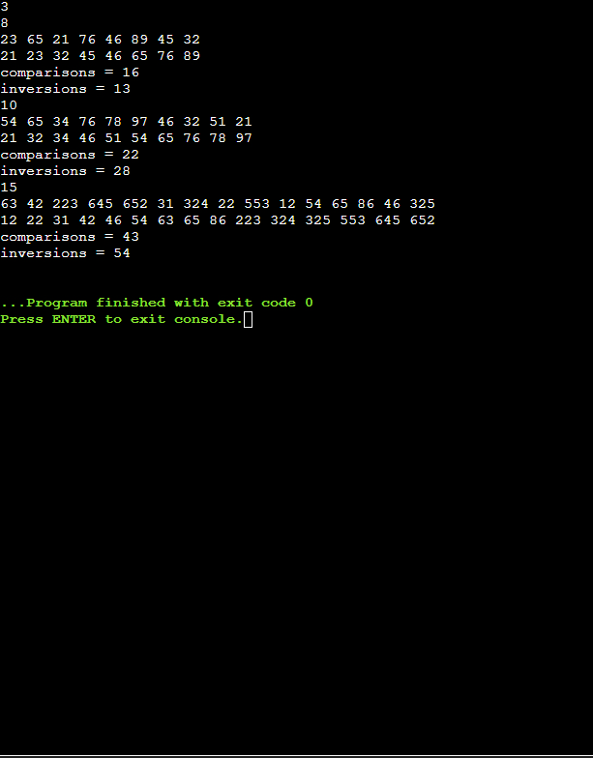

3.
#include <iostream>
using namespace std;
void merge(int arr[], int l, int mid, int h)
{
int count = 0;
int i = l, j = mid + 1;
int temp[1000];
int k = 0;
while (i <= mid && j <= h)
{
if (arr[i] < arr[j])
temp[k++] = arr[i++];
else
{
temp[k++] = arr[j++];
count += mid - i + 1;
}
}
for (; i <= mid;)
temp[k++] = arr[i++];

for (; j <= h;)
temp[k++] = arr[j++];

for (int f = 0; f < k; f++)
arr[f + l] = temp[f];
}
void merge_sort(int arr[], int l, int h)
{
if (l < h)
{
int mid = l + (h - l) / 2;
merge_sort(arr, l, mid);
merge_sort(arr, mid + 1, h);
merge(arr, l, mid, h);
}
}

int main()
{
int T;
cin >> T;
while (T--)
{
int n;
cin >> n;
int arr[1000];
for (int i = 0; i < n; i++)
cin >> arr[i];
int k;
cin >> k;
merge_sort(arr, 0, n - 1);
int flag = 0;
cout << arr[k - 1] << endl;
}
}

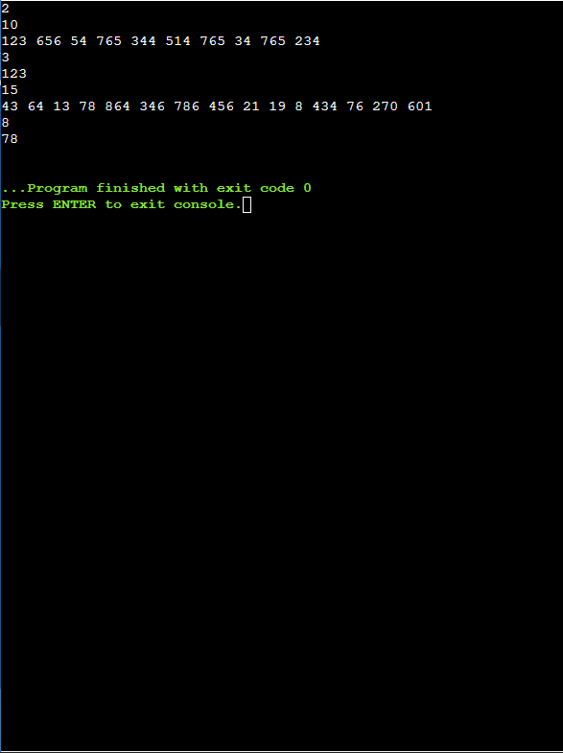

WEEK 5
1.
#include <iostream>
using namespace std;

void countSort(char[], int);

int main()
{
int T;
cin >> T;
while (T--)
{
int n;
cin >> n;
char arr[1000];
for (int i = 0; i < n; i++)
cin >> arr[i];
countSort(arr, n);
}
}

void countSort(char arr[], int n)
{
int count[26] = {0};
for (int i = 0; i < n; i++)
count[arr[i] - 97]++;
int max = 0;
char res = '$';
for (int i = 0; i < n; i++)
{
if (count[i] > max)
{
max = count[i];
res = i + 97;
}
}

if (max == 1)
cout << "No duplicate found" << endl;
else
cout << res << " - " << max << endl;
}

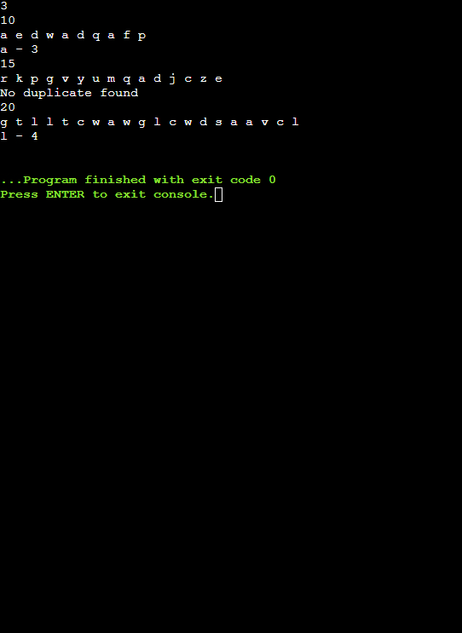

2.
#include <iostream>
using namespace std;
void Quick_Sort(int[], int, int);
int main() {
int T;
cin >> T;
for (int i = 0; i < T; i++) {
int n;
cin >> n;
int A[1000];
for (int j = 0; j < n; j++)
cin >> A[j];
Quick_Sort(A, 0, n - 1);
int x = 0, y = n - 1, sum;
cin >> sum;
for (int j = 0; j < n; j++) {
if (A[x] + A[y] == sum) {
cout << A[x] << " " << A[y] << endl;
break;
}
else if (A[x] + A[y] > sum)
y--;
else if (A[x] + A[y] < sum)
x++;
if (x > y)
{
cout << "No such Element Exist";
break;
}
}
}
}

void Quick_Sort(int a[], int lb, int ub)
{
int i = lb, j = ub, key = a[lb];

if (i > j)
return;

while (i < j)
{
while (key >= a[i] && i < j)
i++;
while (key < a[j])
j--;
if (i < j)
{
int t = a[i];
a[i] = a[j];
a[j] = t;
}
}
a[lb] = a[j];
a[j] = key;

Quick_Sort(a, lb, j - 1);
Quick_Sort(a, j + 1, ub);
}
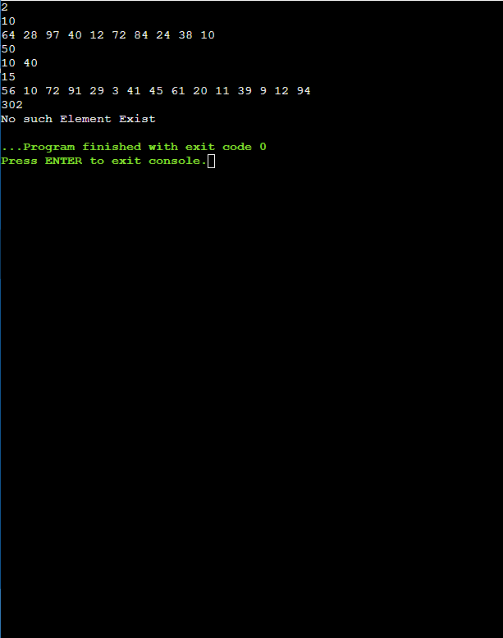

3.
#include <iostream>
using namespace std;
int main() {
int m;
cin >> m;
int A[100];
for (int i = 0; i < m; i++)
cin >> A[i];
int n;
cin >> n;
int B[100];
for (int i = 0; i < n; i++)
cin >> B[i];
int p = 0, q = 0;
while (p < m && q < n)
{
if (A[p] == B[q])
{
cout << A[p] << " ";
p++;
q++;
}
else if (A[p] < B[q])
p++;
else
q++;
}
}

